**Ideation Phase**

**Brainstorm & Idea Prioritization Template**

| Date | 31 January 2025 |
| --- | --- |
| Team ID | NM2025TMID03233 |
| Project Name | Optimizing User, Group, and Role Management with Access Control and Workflows |
| Maximum Marks | 4 Marks |

**Brainstorm & Idea Prioritization Template:**

Brainstorming provides a free and open environment that encourages everyone within a team to participate in the creative thinking process that leads to problem solving. Prioritizing volume over value, out-of-the-box ideas are welcome and built upon, and all participants are encouraged to collaborate, helping each other develop a rich amount of creative solutions.

**Step 1: Team Gathering, Collaboration, and Selecting the Problem Statement**

Our team identified a recurring challenge in organizations where managing users, groups, and roles becomes increasingly complex as the organization grows. Manual role assignments, inconsistent access permissions, and lack of centralized monitoring often lead to inefficiencies and security risks.

This project aims to streamline and automate user management processes in ServiceNow. The solution ensures that users have appropriate access based on their roles, automates approval workflows for access requests, and enhances overall security through better visibility and control.

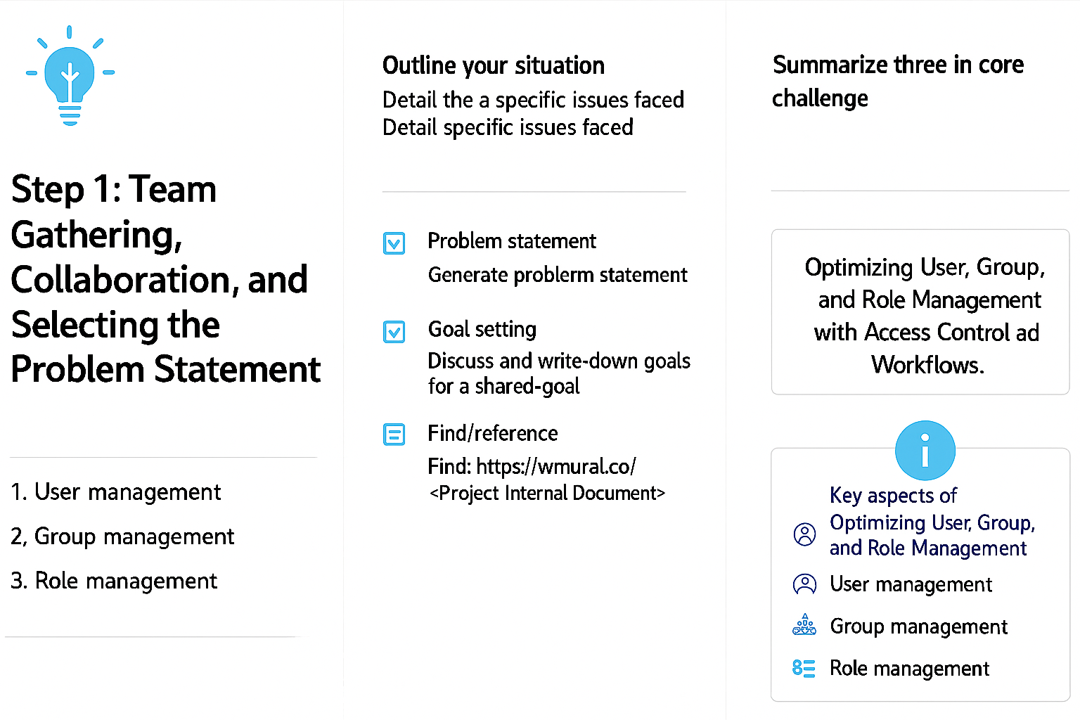

**Step 2: Brainstorm, Idea Listing, and Grouping**

Our team brainstormed ways to improve user, group, and role management in ServiceNow. We discussed and grouped ideas based on security, efficiency, and ease of implementation.

**Key ideas:**

* Centralized module for managing users, groups, and roles
* Automated role assignment workflows
* Approval-based access requests
* Access Control Lists (ACLs) for data security
* Role-based dashboards and reports
* Audit trails and notifications for access activities

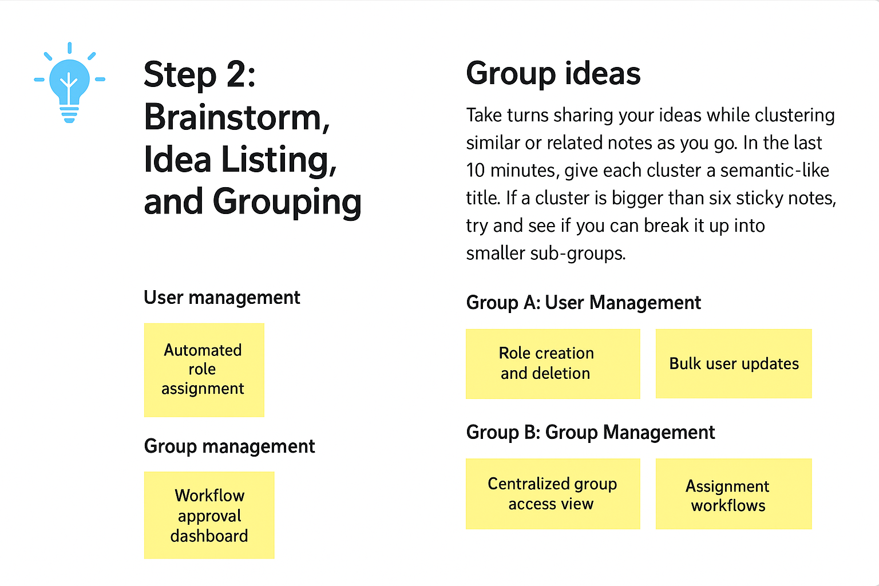

**Step 3: Idea Prioritization**

After evaluating all ideas using impact vs. feasibility analysis, we selected the most valuable and practical features for implementation.

**Prioritized ideas:**

1. Centralized user and role management portal
2. Automated role assignment workflows
3. Access Control (ACL) setup for secured data
4. Approval workflows for access requests
5. Audit logs and real-time notifications

